FTF FY 2023 Performance Scorecard Sahel Regional Program

This Feed the Future (FTF) Performance Scorecard assesses the Sahel Regional Program progress toward FY 2030 Performance Targets.

# Performance Overview



The FY 2023 **On track** value is determined by drawing a line from the baseline (FY 2022) to the FY 2030 Target. For FY 2023, Performance Targets are considered **On track** if they have reported at least 90% of that value.

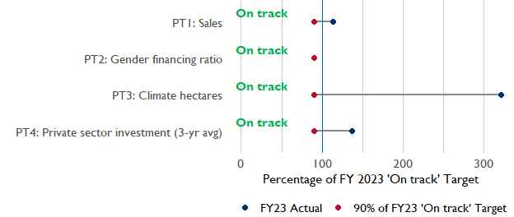

**Note:** *For Performance Target 2 (Gender financing ratio), the target is to increase financing to females for those OUs that are already achieving parity ($1).*

*For Performance Target 4 (PSI), all targets are relative to the last three years’ reporting. In future years, the interim targets may increase.*

*For Performance Target 5 (MDD-W), all FY23 actual values are also the baseline, and may have been collected in a prior year. See the detail page for more information.*

*See detailed* [*methodology document*](https://docs.google.com/document/d/13n-43ppFiGKauscQ7HaAiQDCM4DssGEgRdq2fMyTDn0/edit) *here. If you have questions, please email the FTF Data and Analytics team at* [refs.adl.da@usaid.gov](mailto:refs.adl.da@usaid.gov).

### Performance Target (PT) Details

This section shows PT scores for each applicable PT for Sahel Regional Program.

## Performance Target 1: Value of annual sales of producers and firms receiving USG assistance



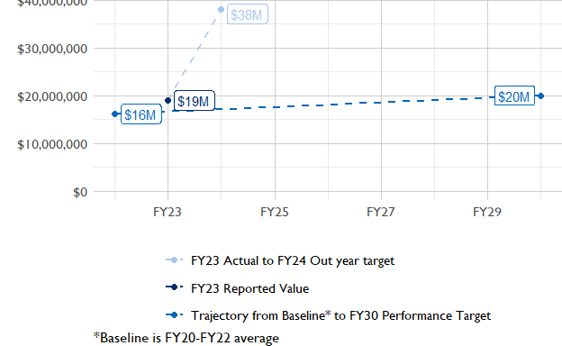

In FY 2023, USAID Sahel Regional Program had 2 activities that aligned the ‘Value of annual sales from producers and firms receiving USG assistance’ (EG.3.2-26), and 2 contributed to the sales total of $18,950,000.

###### Performance Target 2: Value of financing accessed by female FTF participants per $1 of financing accessed by male FTF participants



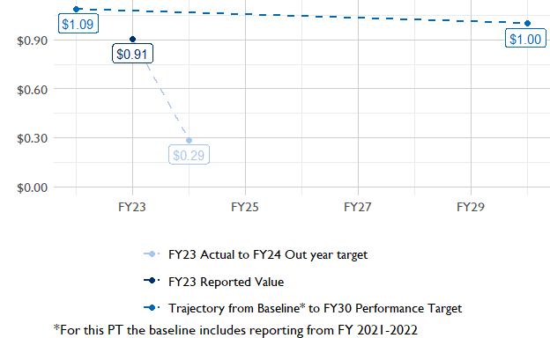

In FY 2023, USAID Sahel Regional Program had 3 IMs/Activities that reported all four sex disaggregates needed to contribute to PT2. The total value of financing among all activities, regardless of disaggregates, was $4,590,000 (EG.3.2-27 total), with $4,590,000 that was disaggregated by females and males, and an additional $8,450,000 to ‘mixed’ firms that have both males and females, and $0 that was not sex disaggregated.

###### Performance Target 3: Number of cultivated hectares under climate adaptation/climate risk management practices and technologies with USG assistance



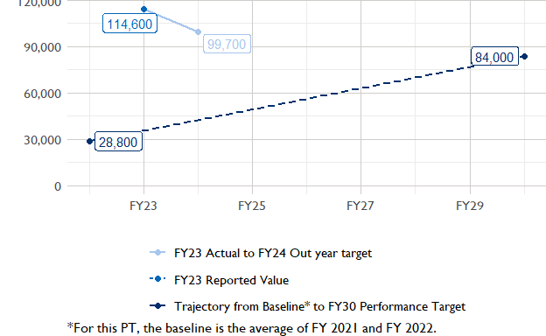

In FY 2023, Sahel Regional Program had 8 activities that aligned the indicator for hectares under improved management practices (EG.3.2-25). Of those activities, 2 reported on the ‘Climate adaptation/climate risk management’ disaggregate and contributed to the OU total for this PT.

###### Performance Target 4: Value of private sector investment leveraged by the USG to support food security and nutrition



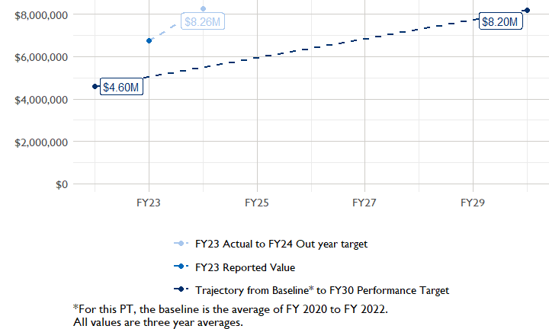

In FY 2023, Sahel Regional Program had 5 activities that aligned the private sector investment indicator (EG.3.1-15/-14), ‘Value of new private sector investment leveraged by the USG to support food security and nutrition [IM-level]’, and 4 contributed to the OU total in FY 2023.

###### Performance Target 5: Percent of women consuming a diet of minimum diversity (MDD-W)



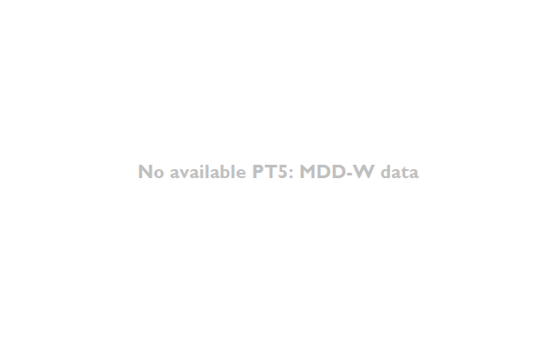

PT5 is not available for USAID Sahel Regional Program.

### National Context

National context data is not available for Sahel Regional Program.

## NULL

## Agricultural Transformation Index Score

The [IFPRI Agricultural Transformation Index (ATI)](https://agrilinks.org/events/drivers-agrifood-system-transformation-lessons-feed-future-country-studies) Score is a high level indicator of the status of agricultural market systems in each country.

## [1] "No Ag Transformation Index available for Sahel Regional Program."

## Budget Trend

At the Operating Unit level, the Performance Targets are based in part on the FY 2024 budget request. The budget chart below includes EG.3 money only.

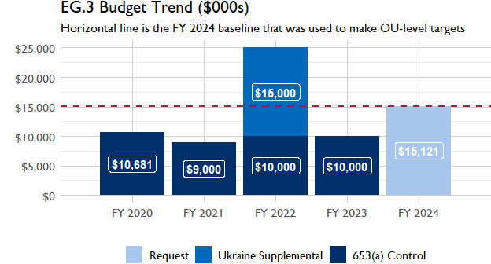

## Active Portfolio

The following activities are considered “active” based on their reporting in FY 2023 and expected FY 2024 reporting. The Analytics, Data and Learning Division defines an “active” activity as one that reported targets, actuals, or deviation narratives for the current year (FY 2023), or the next out year targets (i.e. FY 2024).

## Top Activities (Award Disbursements and Results)

This section highlights some activities in the Sahel Regional Program (SAHEL) portfolio that have the highest level of disbursements and high reporting values for the relevant indicators. The table below shows the top (up to) five activities by the total transaction amount for disbursements. The columns to the right indicate if these activities are reporting on relevant PT indicators.

| Award Number | Activity Code | Activity Name | FY23 Disbursements | PT1 | PT2 | PT3 | PT4 |
| --- | --- | --- | --- | --- | --- | --- | --- |

**The next table (below) shows the top reporting activities.**

| Award Number | Activity Code | Activity Name | Total Disbursements | Sales | Hectares | PSI |
| --- | --- | --- | --- | --- | --- | --- |
| NA | 1365 | USAID Yidgiri | NA | $9,761,986 | NA | $1,017,870 |
| 72062019C00003 | 1348 | Buy-in to West Africa Trade and Investment Hub | NA | $9,191,943 | NA | $9,411,658 |
| 72068519LA00002 | 1362 | TerresEauVie | NA | NA | 114 591 | NA |
| 7200AA19C00080 | 1363 | USAID CATALYZE buy-in | NA | NA | NA | NA |
| AID-625-A-14-00001 | 1356 | SRP01: REGIS-ER | NA | NA | NA | NA |

### Appendix 1: Response to “Not on track” Performance Targets

This section provides space for Sahel Regional Program to provide an explanation of why the following PTs are not on track and how you could adjust to be on track in the coming year(s). To help in your response(s), the relevant section of the FTF/GFS Key Issue Narrative (KIN) is provided, as it *may be* useful in drafting a responses. Note that the KIN is addressing the sum of the out year targets (FY 2023) set by the Sahel Regional Program activities that are reporting on each PT. The FY 2023 out year targets were set prior to the establishment of the FY 2030 Performance Targets, so the below explanations from the KIN may not apply to the Performance Target deviation.

* In Section 4 of the FTF KIN, your OU discusses FY24 and FY25 targets, while these Scorecards are addressing progress against a trajectory from historical reporting to your OU’s FY30 target.  Also, the FY 2023 out year targets were set prior to the establishment of the FY 2030 Performance Targets.  Therefore, the below explanations from the KIN may not apply to these FY30 Performance Target deviations.
* These responses will be used to compile a Congressional report, the GFSS Implementation Report, to discuss progress against the FTF FY 2030 Performance Targets, as mandated by the GAO.
* Only PTs that are ‘Not on Track’ require review and explanation from the OU.

## Performance Target 2: Gender financing ratio

*Excerpt from FY23 KIN Section 4 to consider:* stated FY 2023 target of $13,117,161 in DIS did not include some of the WATIH targets, resulting in the appearance of a lower target that unfortunately cannot be edited. The actual FY 2023 target was $29,061,583, and that higher figure was not achieved. In Burkina Faso, USAID WATIH fell short of its sales target of $15,577,027 by 62 percent due to increased unpredictability in some regions where the grantees are operating. This “unpredictability” is the result of a number of contextual factors beyond USAID’s control, namely increasing violence, instability and market disruption. Farmers are understandably anxious and distressed due to increased banditry, reports of armed individuals invading their property, and kidnapping, which is deterring them from focusing fully on their farming operations. In certain areas, these security issues have significantly impacted farmers’ capacity to complete harvests, inevitably impacting sales. As stated above, many of the factors that prevented us from reaching our targets are beyond USAID’s control. USAID will continue to adapt activities as possible, but the broader instability and uncertainty will likely continue to constrain production and sales, and therefore have a negative impact on our results moving forward. The overall target for this indicator was not met in FY 2023. USAID Yidgiri failed to reach the target of $411,687 by 66 percent, primarily due to insecurity. Microfinance institutions continue to close their branches in the communities of interventions. In addition, the capacity of union leaders to develop loan applications and negotiate loans remains low despite the capacity-strengthening support received. USAID CATALYZE results were below the targets for this indicator (-27.75 percent). There was heightened insecurity and instability in target regions. In addition, there was closure of certain FI partners’ branches/locations as they no longer provide credit within 15 km of urban centers. The eligibility conditions for credit renewals changed which resulted in the exclusion of several transactions which were judged ineligible in calculating the value of private capital mobilized during the period. Furthermore, there were delays in grants approval by the donor as well. Similarly, USAID WATIH was below its target in Cabo Verde by 18 percent. However, the activity exceeded the FY 2023 target in Burkina Faso and Niger by more than 35 percent. The over-achievement is primarily due to additional clients reached by some grantees like Agroserv and Sinergi Burkina.

#### Enter Sahel Regional Program (SAHEL) Response Below: